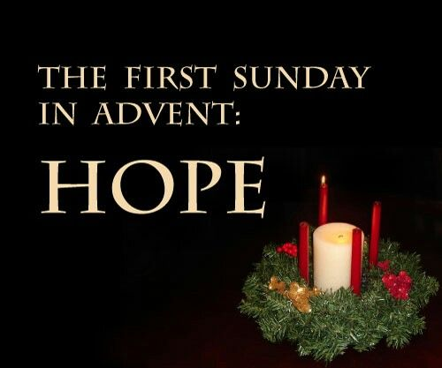 Ministry

@Home

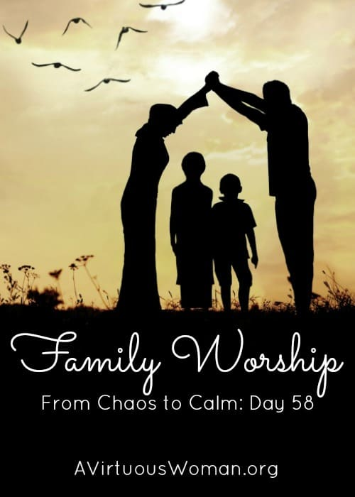

**These resources are to help equip & enable worship together as “family”. They are intentionally intergenerational to allow space, conversation, activity & response together as the family of God. We encourage all ages to be participative & open, being responsive to God and each other.**

**Welcome…..**

**Song: Rescuer (can be sung or listened to)**

<https://www.youtube.com/watch?v=leh-4fCc5MI>

**Reflection time:** The meaning of the word Adventis the arrival of a notable person. The arrival of advent for us is to take this time in our lives to think about who the notable person is. Share with each other who you think notable (special) people are? What are their qualities and what makes them notable (special)? Write these down for later.

As we begin to decorate our homes for Christmas remembering Jesus birth over the next 4 weeks of Advent, we will be taking time in our lives and time to prepare our hearts for Jesus’ arrival – just as we prepare our homes we need to prepare ourselves too. Week 1 of Advent is **HOPE**, we often see advent rings with candles and each candle represents different people and values.

The **first** represents the patriarchs in the Bible that predicted the coming of Jesus. Jesus is our **HOPE.**

If you have an advent wreath or an advent candle in your home you could now light this candle and think about the **HOPE** we have in Jesus.

A 2 min video introducing Advent can be found

<https://www.youtube.com/watch?v=eC0FGQLBp7w>

**Bible passage:** Read together Isaiah 64.1-9 & 1 Corinthians 1.3-9

Notice the promise and **HOPE** of God in Isaiah and Faithfulness and **HOPE** in Corinthians.

**Gather……**

* As you gather find a place that is comfortable and have the resources ready for the activities, prayer or response times ready.
* Choose 3 members to light the 3 candles (engage all ages)

**Opening words of praise with lighting of 3 candles -**

I will light a light

in the name of the Maker,

who lit the world

and gave everything life.

I will light a light

in the name of the Son,

who saved the world

and stretched out his hand to me.

I will light a light

in the name of the Spirit,

who is present everywhere in the world

and gives me strength.

**Together:**

**We will light three lights**

**for the trinity of love:**

**God above us,**

**God beside us,**

**God beneath us;**

**The beginning,**

**The end**

**and the Everlasting one.**

**Interactive Learning……**

**Hope is a belief.**

**HOPE** is what we hang on to when things are not going the way we expected or when times are tough. It gets us through, it gives us that glimmer that we simply can’t ignore. It sparks a feeling in us. The **HOPE** we find in Jesus can get us through. The prophets of the Old Testament, especially Isaiah, waited in **hope** for the Jesus’ arrival.

This picture will be on the sheet every week – colour the candle for this week. **HOPE**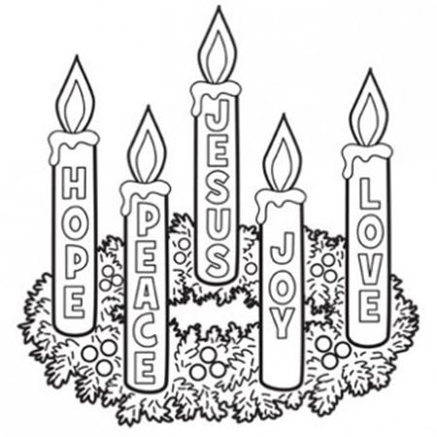

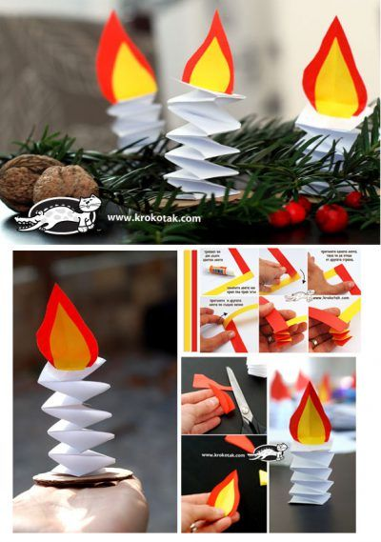

Create candles of **HOPE** on the flame you could write the names of people who you know need the **HOPE** of Jesus at this time.

**Giving HOPE Advent Calendar**

Go back to your paper with qualities/values of a notable person, see if you can now make the list longer by adding other qualities, up to 24 if possible. On each small piece of paper write a value or qualitiy and then how you could display that quality or value to/for another member of your family/bubble. Place one of the 24 qualities/values individualy into the 24 evenvoples. Number each envelope 1-24. As advent progressess each day let a family member open an envelope – the challenge is then for that person to display that quality/value towards the other members of your household/bubble until the next envelope is opened the next day.



**Whilst creating chat about the following questions & Share stories…..**

* Share when you have felt **HOPE**less what happened or who made you feel more **HOPE**ful?
* Who could you bring **HOPE** to this week? Discuss who Jesus might be asking you to bring some **HOPE** to

Let each person you are gathered with take a look at the sheet and spot how many times you see the word **HOPE**

**Reflection & Prayer Time…..**

**As you come together for a time of prayer listen and watch the following video – reflect and share within your gathering on the fact that Jesus came for the whole world and how the whole world can rejoice**

**Song:**  **The Splendour of the King – World Version**

<https://www.youtube.com/watch?v=8Uux60fPkXk>

Encourage members to read silently or aloud their prayers/person from their **HOPE** candle. Other prayers can be said at this time, concluding with the Lord’s Prayer

**The Lord’s Prayer**

**Our Father in heaven,**

**hallowed be your name,**

**your kingdom come,**

**your will be done,**

**on earth as in heaven.**

**Give us today our daily bread.**

**Forgive us our sins**

**as we forgive those who sin against us.**

**Lead us not into temptation**

**but deliver us from evil.**

**For the kingdom, the power,**

**and the glory are yours**

**now and for ever.**

**Amen.**

**Celebration….**

**If any of your members celebrate a birthday within the next week – sing**

Happy birthday to you  
To Jesus be true  
May God's richest blessings   
Be showered on you.

Extra Ideas

* <https://childrensministry.com/the-12-ideas-of-advent/>
* <https://thatresourcesite.com/thatresourcesite/advent-resources/>
* Music that can be played whilst creating

<https://www.youtube.com/watch?v=bkeI8C2CJz0>

<https://www.youtube.com/watch?v=r_t5xitQjIc>

**Closing Responses…………**

**Song: This is Amazing Grace**

<https://www.youtube.com/watch?v=ZxVadCcRfoI>

**(can be sung/read aloud or listened to)**

From where we are  
to where you need us.

**Jesus, now lead on!**

From the security of what we know  
to the adventure of what you reveal.

**Jesus, now lead on!**

To make this world  
look more like your kingdom,

**Jesus, now lead on!**

**Ask different members to blow out the candles…………..until you meet again**

**Closing……**

**The Grace (with “Messy” actions)**

**May the grace of our Lord Jesus Christ,  
and the love of God,   
and the fellowship of the Holy Spirit   
be with us all,   
now and evermore. Amen.**