Job 12v7 “But ask the animals, and they will teach you, or the birds in the sky, and they will tell you; or speak to the earth, and it will teach you, or let the fish in the sea inform you. Which of all these does not know that the hand of the LORD has done this? In his hand is the life of every creature and the breath of all mankind.

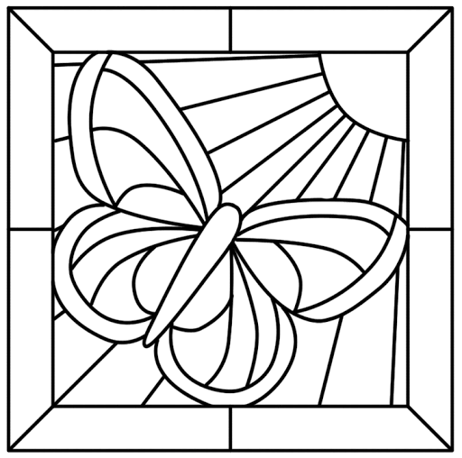
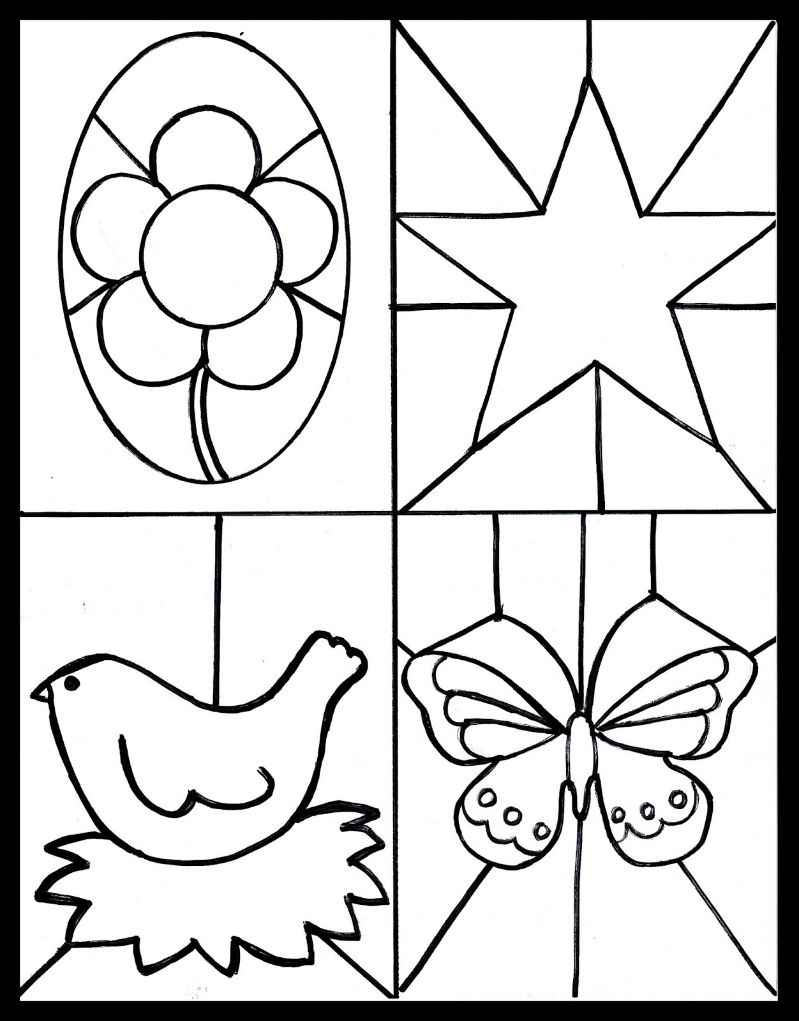
Psalm 19 v 1
The heavens declare the glory of God
the skies proclaim the work of his hands.

